LESSON TWO: IDENTIFYING COMPUTER SYSTEMS
INTRODUCTION
Before performing any assessment of computing system controls, all of the computing systems utilized by an organization must be identified. Creating an inventory of computing systems is essential so that the size and complexity of the computing system environment, or “universe,” within an organization can be assessed.
The inventory should include:
- Systems that have been developed internally as well as those purchased from vendors.
- Systems in which an organization’s data is processed by an external vendor’s computer system (these vendors are often referred to as service bureaus, third-party processors, or service organizations).
An organization’s computing system inventory may prove to be quite challenging. Do not be surprised if the number of computing systems reaches into the thousands.
A computing system is generally defined as any computer software application that performs a business function; the supporting database management system, if any; the hardware on which it resides and that provides access to it; and the operating system that controls the hardware. Computing systems include hardware devices that reside within an organization or at a vendor site as well as software programs that are written and maintained by internal programmers, purchased from and maintained by vendors, or reside at third-party processor sites.
Once the “universe” of computing systems in an organization has been identified, the systems must be categorized by criticality; essentially a risk analysis must be performed on them.
The best method for evaluating the risk of the computing systems must be determined. For some it may be in terms of total dollar value of items processed by the system, while for others it may be the total number of items processed, total cost or investment in the system, potential losses if the system were corrupted, a combination of these criteria, or some other factors that may be deemed appropriate.
One way to create an inventory is to begin by surveying managers within each work group. If the organization is large, a written survey form may need to be created and sent to the managers. In a small organization, telephoning managers and verbally asking them for the required information may be a more efficient way to complete the survey.
As the term auditor implies, one can often identify computing systems, especially those being proposed or those that are in the early stages of development, by what one hears during conversations with others in the organization or even through the grapevine. Case study 2.1 describes a situation in which an unknown aspect of an e-mail system was identified through the company grapevine.
Another way of identifying computing systems is to deploy some sort of network search program that identifies all executable files. Such a tool is also helpful in identifying pirated or other unauthorized software. However, this method will not identify all third-party processor systems or Internet-based applications.
Optimally, a combination of methods should be used to identify all systems.

Benefits of a Computing System Inventory
Once completed, the computing systems inventory can provide several useful benefits.
First, it will help in assessing the size and complexity of the computing systems environment within the organization. Some computing systems of which one was unaware may be identified. A second benefit of the computing systems inventory is that it can help to identify work areas where the same or similar data is being stored and utilized. In these cases, there may be opportunities for consolidation of data storage resources and data processing resources, potentially resulting in reduced expenses and increased efficiency.
A third benefit is that the inventory can help both internal and external audit management in planning what computing systems to examine and in budgeting human resources and the necessary dollars to perform the examinations.
Risk Assessment
Now that the computing systems in an organization have been identified, one has the necessary information to begin performing a risk assessment of the IS environment.
Additional data regarding the dollar amounts, transaction volume, and other information should be obtained to enable ranking of the computing systems from most risky to least risky. It is a good idea to record all the computing system demographic information in a spreadsheet, database, or other audit planning application.
The computing systems can then be sorted by various criteria, such as process owner, dollar volume, operating system, and application type. Often this can aid in audit efficiency and effectiveness by assisting in determining which audits need to be performed and the order in which they should be performed. As previously mentioned, special over-the-counter software applications are available to assist in the risk assessment process. However, such software is by no means a requirement. An internally developed spreadsheet or database application may be quite sufficient.
Sample Inventory for Finance Institution
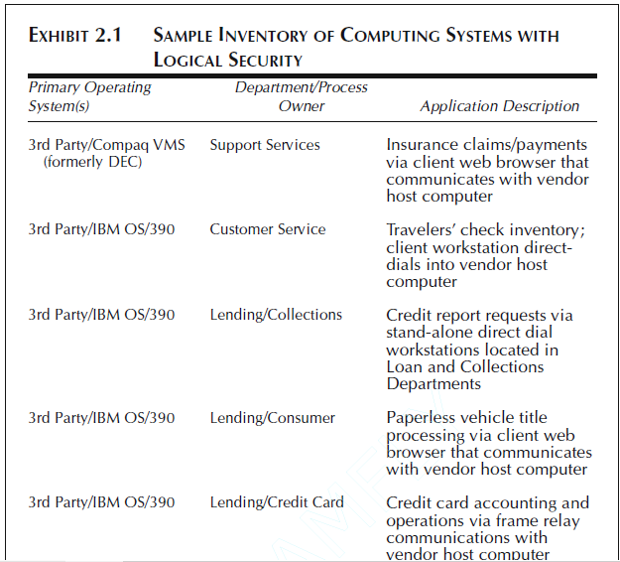

Sample Risk Assessment Matrix
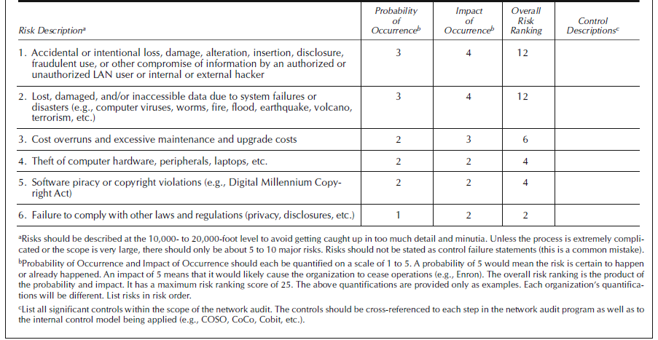
Based on the results of the risk assessment, the highest-risk computing systems can be selected and audits of their controls can be performed.

